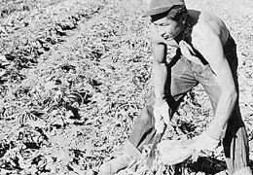
Japanese Evacuee Tops Sugar Beets // CN 021008
This 1943 Oregonian photograph shows a Japanese-American “evacuee” topping sugar beets in Nyssa, located on the Idaho border in southeast Oregon. During World War II, the federal government forced West Coast Japanese immigrants and Japanese Americans to leave their homes for internment camps or inland states. Because of an acute agricultural labor shortage, Malheur County was the only place in Oregon where Japanese were allowed to live outside of internment camps. Prior to the war, some Japanese families already lived in the area.
The Amalgamated Sugar Company and state officials convinced President Franklin D. Roosevelt to allow an evacuation exception, providing Japanese internees the choice of working in Malheur County. In early May, 1942, several hundred Japanese families moved into a former Farm Security Administration (FSA) camp located near Nyssa. The Amalgamated Sugar Company, which owned a sugar beet factory in Nyssa, paid their wages and living expenses. Before the war ended, many of the Japanese moved to the farms where they worked.
While many local farmers welcomed the Japanese laborers, and appreciated the quality of their work, anti-Japanese sentiment was evident. County officials attempted unsuccessfully to prevent Japanese Americans from owning land in the area. In addition, some town residents expressed resentment, claiming that the workers were too demanding when they negotiated that electricity be wired to their camp.
After the war, many Japanese families stayed in the area. In 1960, the census reported that 1,136 people of Japanese heritage were living in Malheur County.

