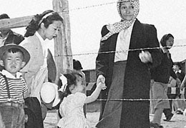
Heart Mountain Relocation Camp // OrHi 44601
This World War II photograph shows a Japanese American family at the Heart Mountain Relocation Center, located in northwest Wyoming. During the war, the government forced West Coast Japanese immigrants and Japanese Americans to leave their homes and move to internment camps. A small percentage of Oregon’s roughly 4,000 Japanese went to Heart Mountain, where more than 10,000 were detained. Most of Oregon’s Japanese population went to the Minidoka Relocation Center in southern Idaho, and others went to the Tule Lake Relocation Center in Northern California.

In the Pacific Northwest, existing hostility against Japanese people increased after Japan attacked Pearl Harbor on Dec. 7, 1941. The government declared that immigrant Japanese — issei — were “enemy aliens” and many issei men were detained by the FBI. On Feb. 19, 1942, President Franklin D. Roosevelt issued Executive Order 9066, authorizing the army to remove issei and American-born Japanese, who were citizens — nisei — from the West Coast.

The order devastated Oregon’s Japanese community. People were forced to sell their property at below-value prices and to abandon businesses. The army first took internees to assembly centers with primitive facilities, where they lived for months before being transported to permanent camps. Life at the Heart Mountain Relocation Center was harsh. The barracks were roughly-built and poorly-insulated, and the landscape was barren.

