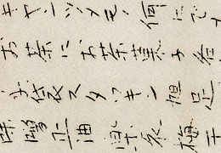
Notice on Yasui Brothers Store, Hood River // Mss 2949
The day after Japan attacked Pearl Harbor in December, 1941, the U.S. Treasury Department shut down the Yasui Brothers Store in Hood River. Five days later, the FBI arrested Masuo Yasui, who had owned the store with his brother, Renichi Fujimoto, for more than thirty years. The U.S. government wrongly suspected Yasui of spying for Japan, probably because he had received a special award from the Japanese government — a Paulownia Cup. Fujimoto posted this notice on the store in March 1942, when the government allowed him to reopen it for a one-month clearance sale.
The brothers were forced to sell their merchandize under value and close the store permanently after President Franklin D. Roosevelt signed Executive Order 9066, which allowed the army to force all West Coast Japanese immigrants and Japanese-Americans leave the region during World War II. The U.S. Army sent 3,714 Japanese from Oregon to internment camps in Idaho, Wyoming, and northern California.
The government determined that Yasui was a “potentially dangerous” alien enemy, and imprisoned him separately from his family in an “alien detention” camp. He wasn’t released until several months after the war ended. Yasui’s son, Minoru, spent time in solitary confinement during the war because he legally challenged a wartime curfew placed on Japanese Americans.

