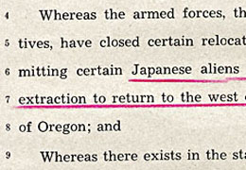
Oregon House Joint Memorial Number 9 // Mss 1498
Oregon State House representatives Vernon D. Bull (Democrat-La Grande), Warren Erwin (Democrat-Portland), and Rose M. Poole (Republican-Klamath) issued this joint memorial Feb. 28th, 1945. The memorial represents an unsuccessful effort to prevent Japanese immigrants and Japanese Americans from returning to the state after being held in internment camps during World War II. At the time this memorial was submitted, the war between the United States and Japan had not yet ended and anti-Japanese sentiment was high in Oregon and the nation.
Ex-governor Walter M. Pierce lobbied with members of the grange, farmers, and the American Legion, to prevent Japanese internees from returning to the state. As a result, the legislature passed an amendment in 1945 to Oregon’s 1923 Alien Land Law, preventing Japanese immigrants from owning land, leasing farmland, and living or working on farmland owned by Japanese Americans. Nationally, the government did not allow Japanese immigrants to become citizens until 1952.
After World War II, many of the 4,000 Japanese forced to leave Oregon did not return to the state. Those who did return often faced blatant hostility, harassment, threats, vandalism, and even violence. In Hood River, American Legion member Kent Shoemaker bought several full-page newspaper advertisements — one signed by 1,500 local residents — stating that “Japs are not wanted in Hood River.” In contrast, other community groups supported the Japanese and helped returning internees find housing and jobs.

